**Simple Java Maven App**

1. Install java in Jenkins Master server from the link below :

wget <https://corretto.aws/downloads/latest/amazon-corretto-8-aarch64-linux-jdk.tar.gz>

2 . Under Jenkins Dashboard, Click on Manage Jenkins and then Click on Global Tool Configuration and update the JDK path as given below

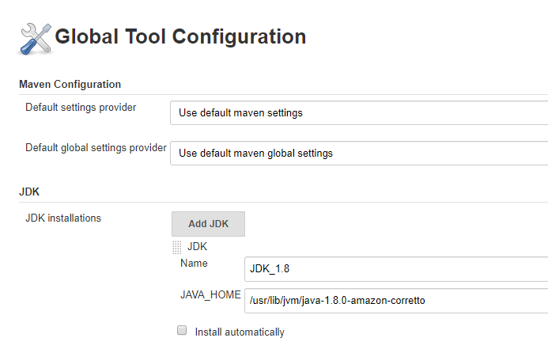

3. Install Maven in Jenkins Master by following the below steps:

sudo wget http://repos.fedorapeople.org/repos/dchen/apache-maven/epel-apache-maven.repo -O /etc/yum.repos.d/epel-apache-maven.repo

sudo sed -i s/\$releasever/6/g /etc/yum.repos.d/epel-apache-maven.repo

sudo yum install -y apache-maven

Check version using the command -- > mvn –version

4. In the Global Tool Configuration of Jenkins add Maven path as below:

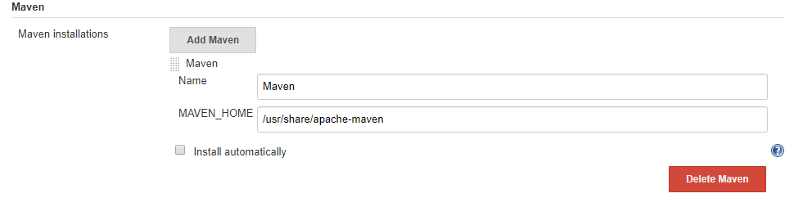

1. Create a repo in GitHub and push the below code to the Git repository

root@ip-172-31-85-119 JenkinsProject]# pwd

/root/JenkinsProject

[root@ip-172-31-85-119 JenkinsProject]# ls -ld simple-java-maven-app/

drwxr-xr-x 5 root root 4096 May 3 16:11 simple-java-maven-app/

1. Create a new pipeline project and configure SCM details as below

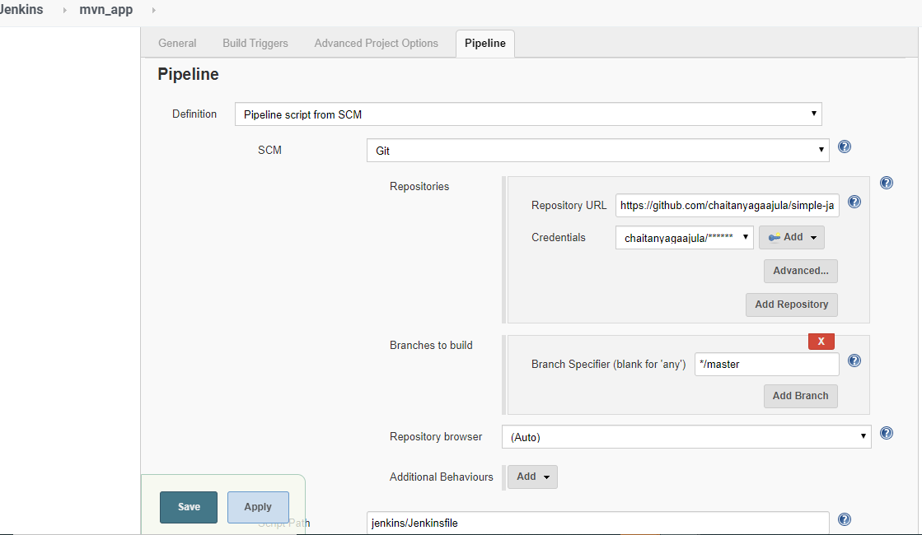

1. Save and Build the Job
2. In the console Output we can see a Jar has been build using maven and displays Hello World

